Problem Description

The mission involves designing and building a TurtleBot3 Burger system equipped with a IR (heat) detection module and a projectile launcher capable of autonomously navigating a 5m x 5m maze with walls under 1m in height. Within the maze, the robot must locate a designated heat signature zone marked by an IR lamp enclosed in a randomly placed space and identify three "hot targets" — biscuit tins emitting infrared heat and marked with vertical position indicators 1.5m above them. Upon locating a hot target, the robot must orient itself, aim, and fire three ping pong balls at the vertical marker in a specified 2s–4s–2s timing sequence.

Fig 1: Mission Layout


Figure 1: Mission Layout

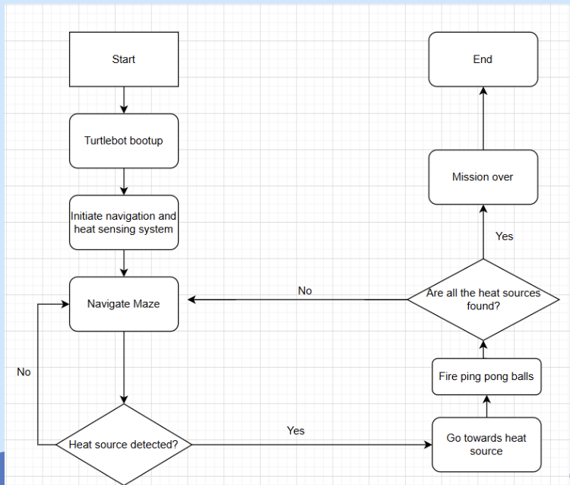

Figure 2: General Con-Ops Overview

| Stakeholder Requirements | Project Deliverables |
| --- | --- |
| Traverse map autonomously | Implement mapping techniques to generate real time map of maze |
| Avoid obstacles | Develop capability for obstacle avoidance and navigation |
| Detect Heat source | Detect heat readings and trigger launcher when above threshold |
| Fire Flares above 1m | Generate enough power to fire ball above 1m |
| Fire at interval | Incorporate firing timing at 2-4-2 intervals |

| Stakeholder Requirements | Functional Requirements |
| --- | --- |
| Traverse map autonomously | Using SLAM incorporate frontier exploration and path planning algorithm to continuously update and refine map during exploration |
| Avoid obstacles | Utilise sensors and lidar to detect obstacles and navigate around them |
| Detect Heat source | Using heat sensor set threshold and create code such that when threshold is hit, launch mechanism triggers |
| Fire Flares above 1m | Use flywheel mechanism ,rack and pinion system to load balls into flywheel mechanism |
| Fire at interval | Using servo adjust speed at which balls are loaded into the flywheel |

| Constraints | Description |
| --- | --- |
| Cost | 80 Dollar budget |
| Power | Operate within constraints of power source |
| Sensor | Limited by cost and availability |
| Processing power and memory | Limited due to Rpi, affects algorithm efficiency |
| Size | Fit within walls and passages of the maze |